(1) Look for the pattern ‘Meningoma’ in the data file. Redirect the output to a new file called ’LinesWithMeningoma.out’. Show the command used and the contents of this new file in your screenshot.

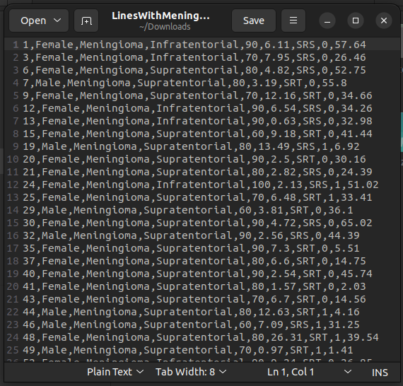

(2) How many males and females were present in this study? How will you create a grep filter to find this out?
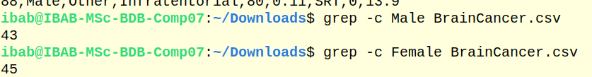
(3) How many males have supratentorial brain cancer and how many females have infratentorial cancer? Which option in grep makes you ignore the case while searching? Make use of this in this exercise.

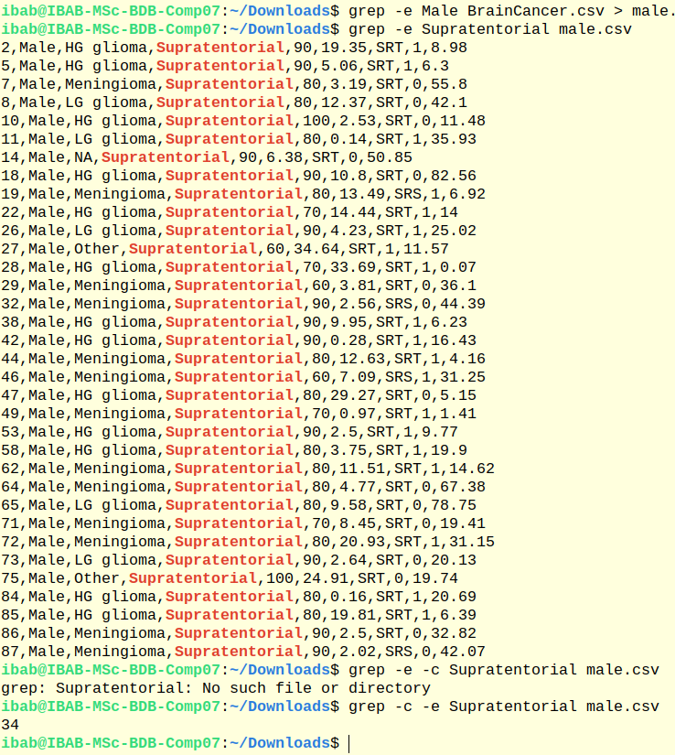

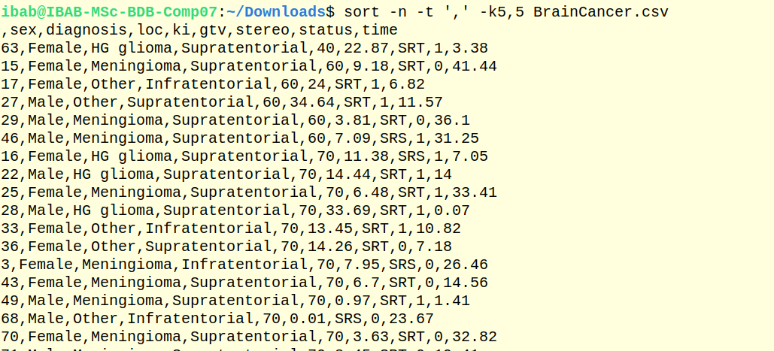
(4) Find out which patient has the lowest ki value. (Hint: Use sort for this, it’s easier)

5.Print out the output by searching for the patterns ’SRS’ as well as ’infratentorial’. How many such entries are there?

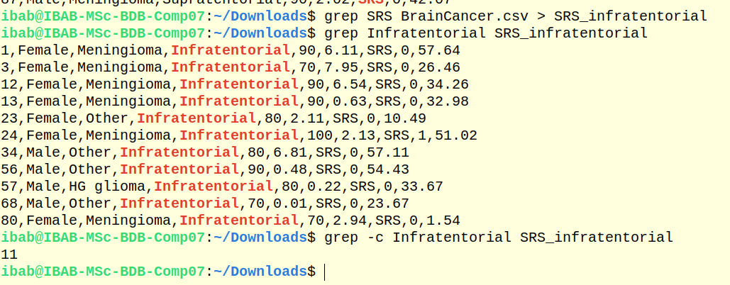

(6) List the patients who have survival times more than 50 months.
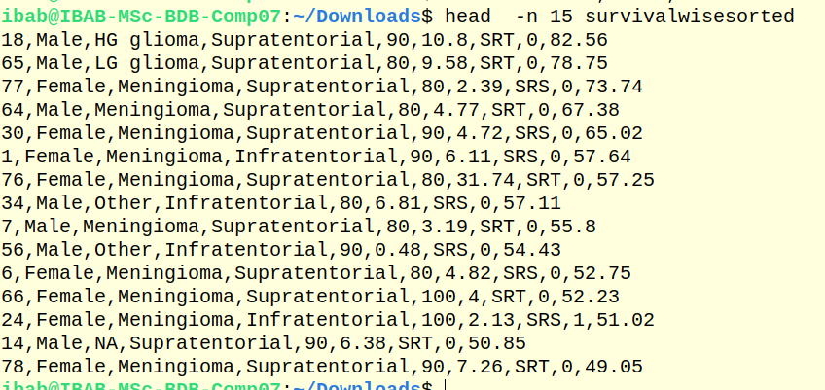

7)List the patients who have HG glioma and have survival times more than 50 months.How many are there?
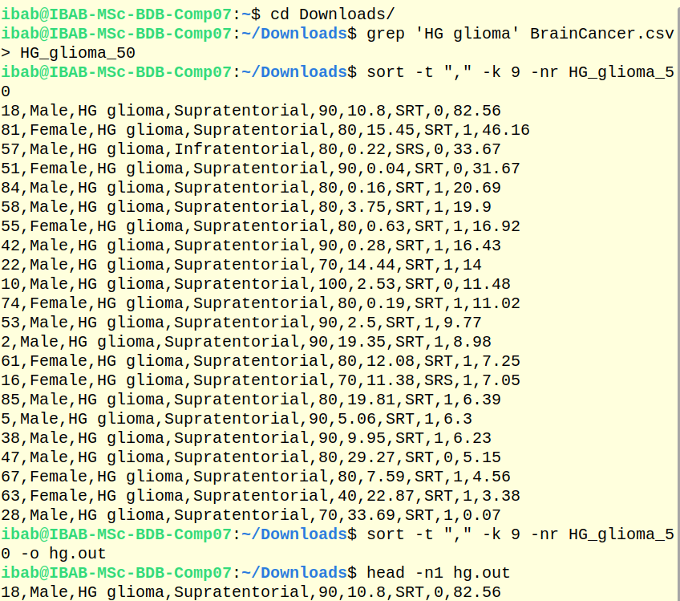
8)List the patients who have LG glioma with location supratentorial and survial times less than 30 months. How many are there?

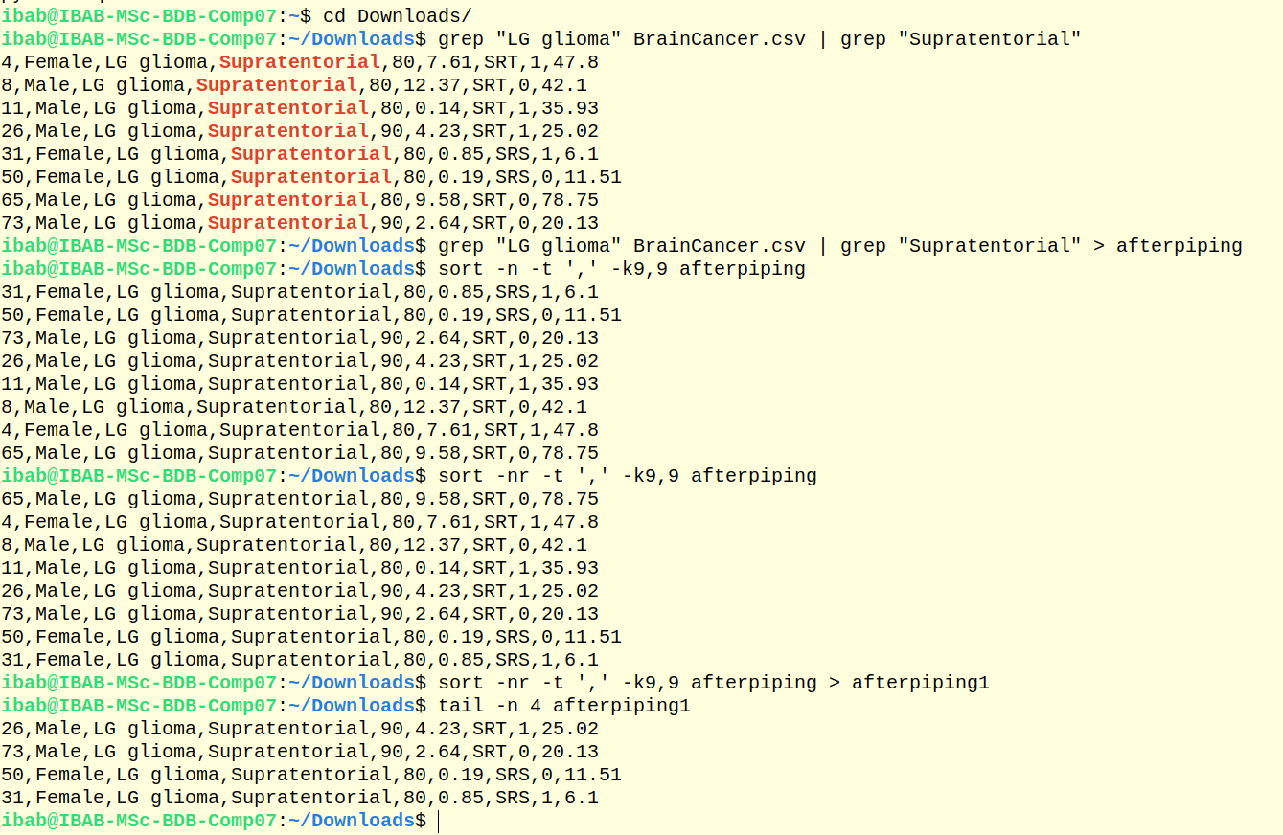

9)By default does grep ignore or not ignore case? Demonstrate this by using the appro-priate option and by running the grep command without this option.

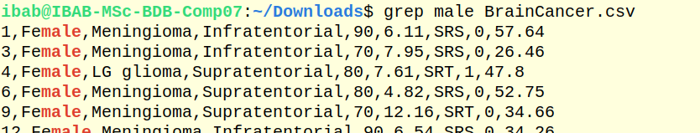
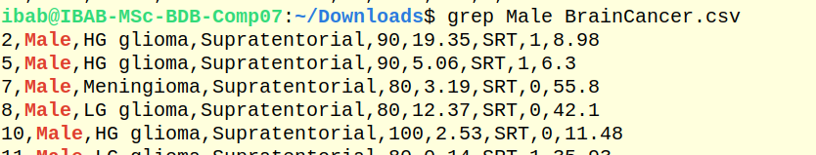
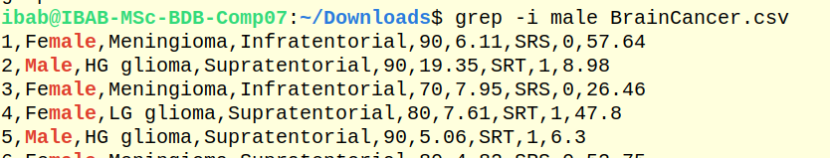

(10) List the patients who are dead at the end of the study. How many are there? Find another way to listing this set of patients (look up grep man pages to look for a specific option to select non-matching lines)

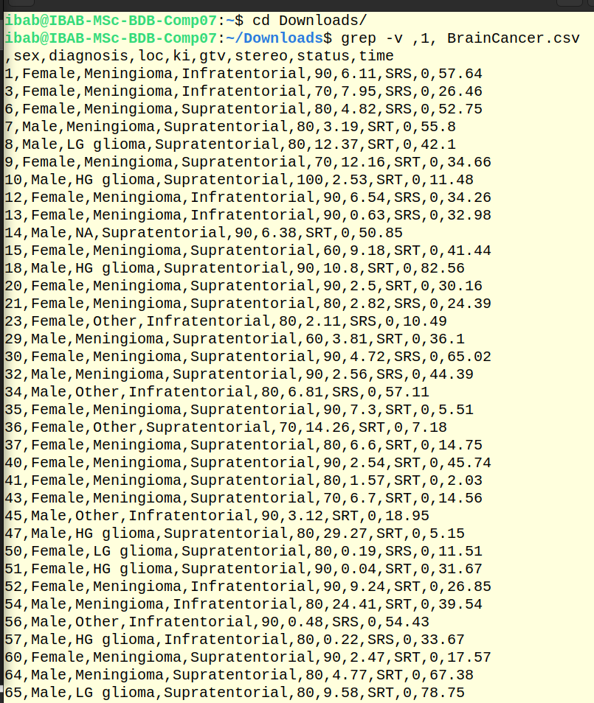

11)Let’s list the patients who have their cancer in infratentorial location. How many are there? How do I restrict the output to first ten patients?
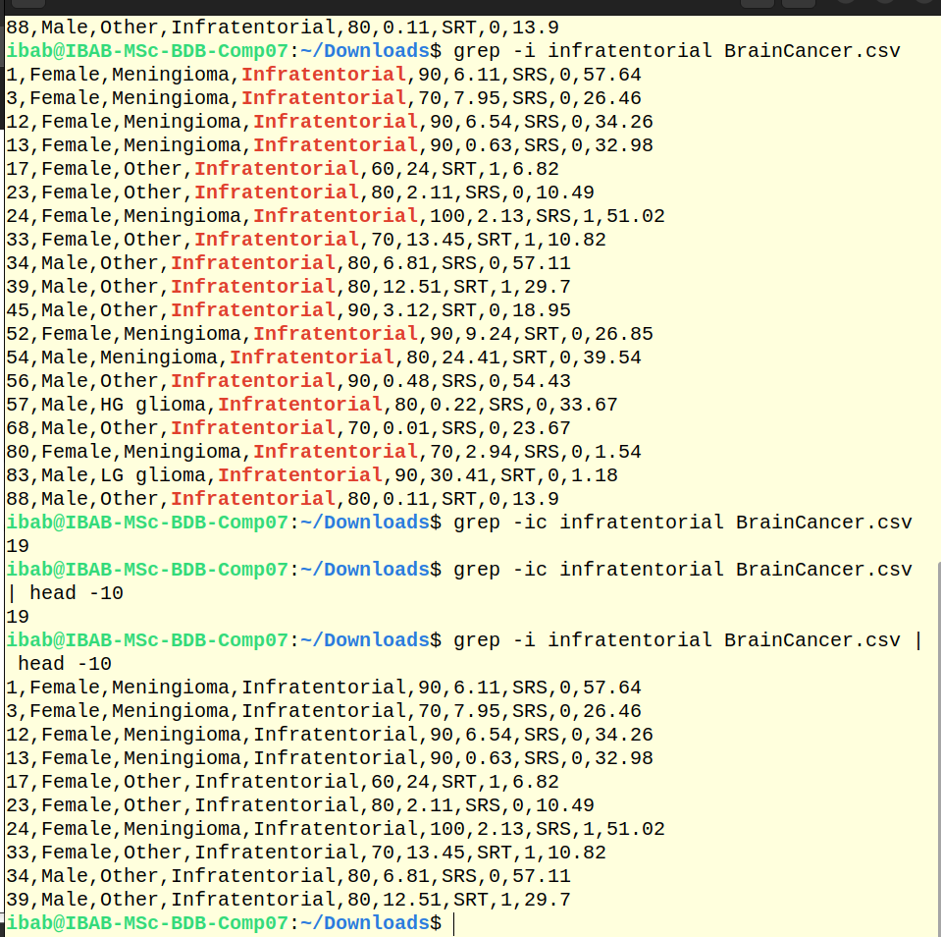

12) Create an archive file by combining the outputs of questions 1-5.

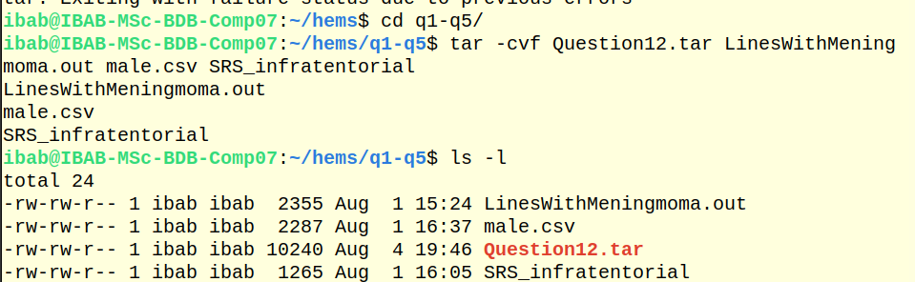

13) Create a zipped and archived file by combining the outputs of questions 6-11.
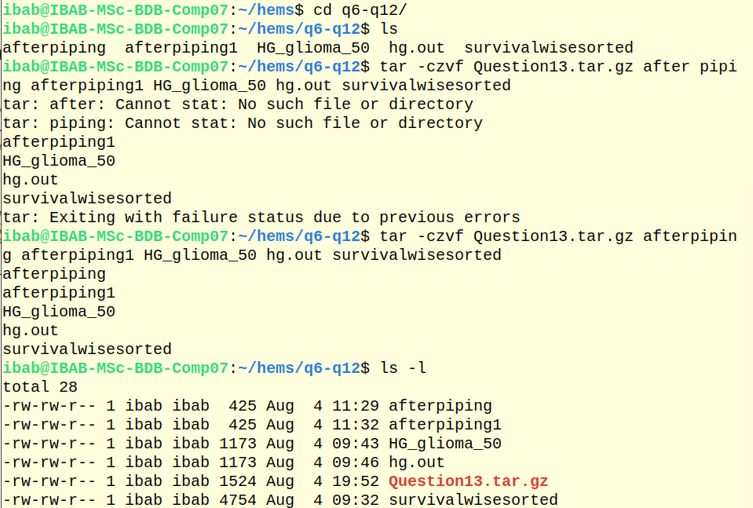

14.List and extract the contents of the archive file created in (12) to a new directory and list the contents of the new directory.
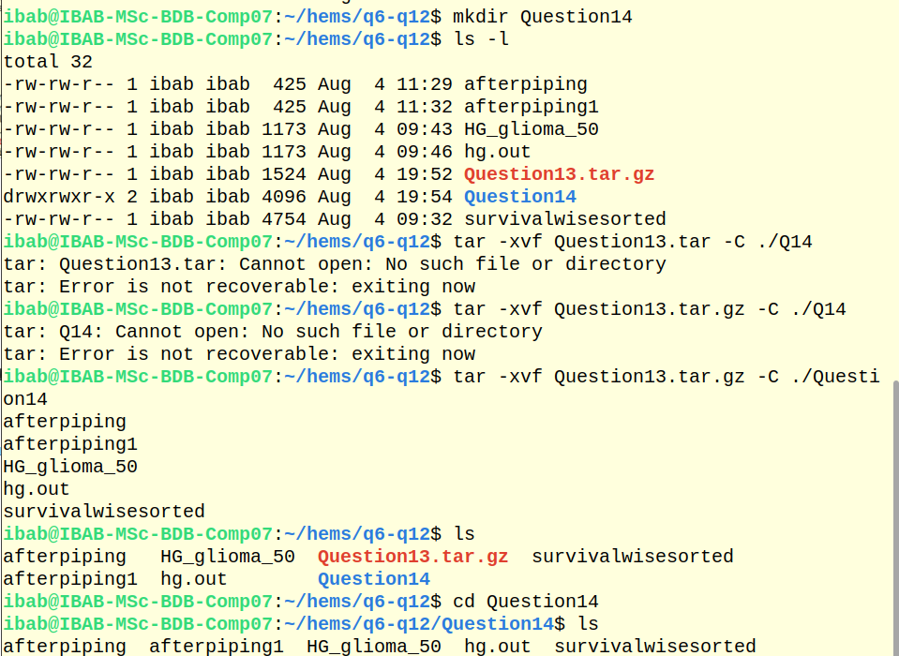

15) List and extract the contents of the archived-zipped file in (13) to a new directory and list the contents of the new directory.
